**CONNECTING MULTIPLE MOTORS TO ARDUINO MEGA BOARD**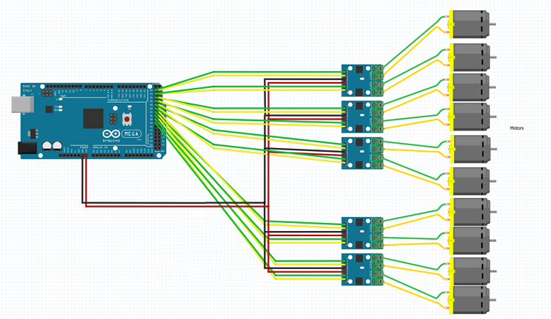

**CONNECTING KEYPAD TO ARDUINO MEGA BOARD**

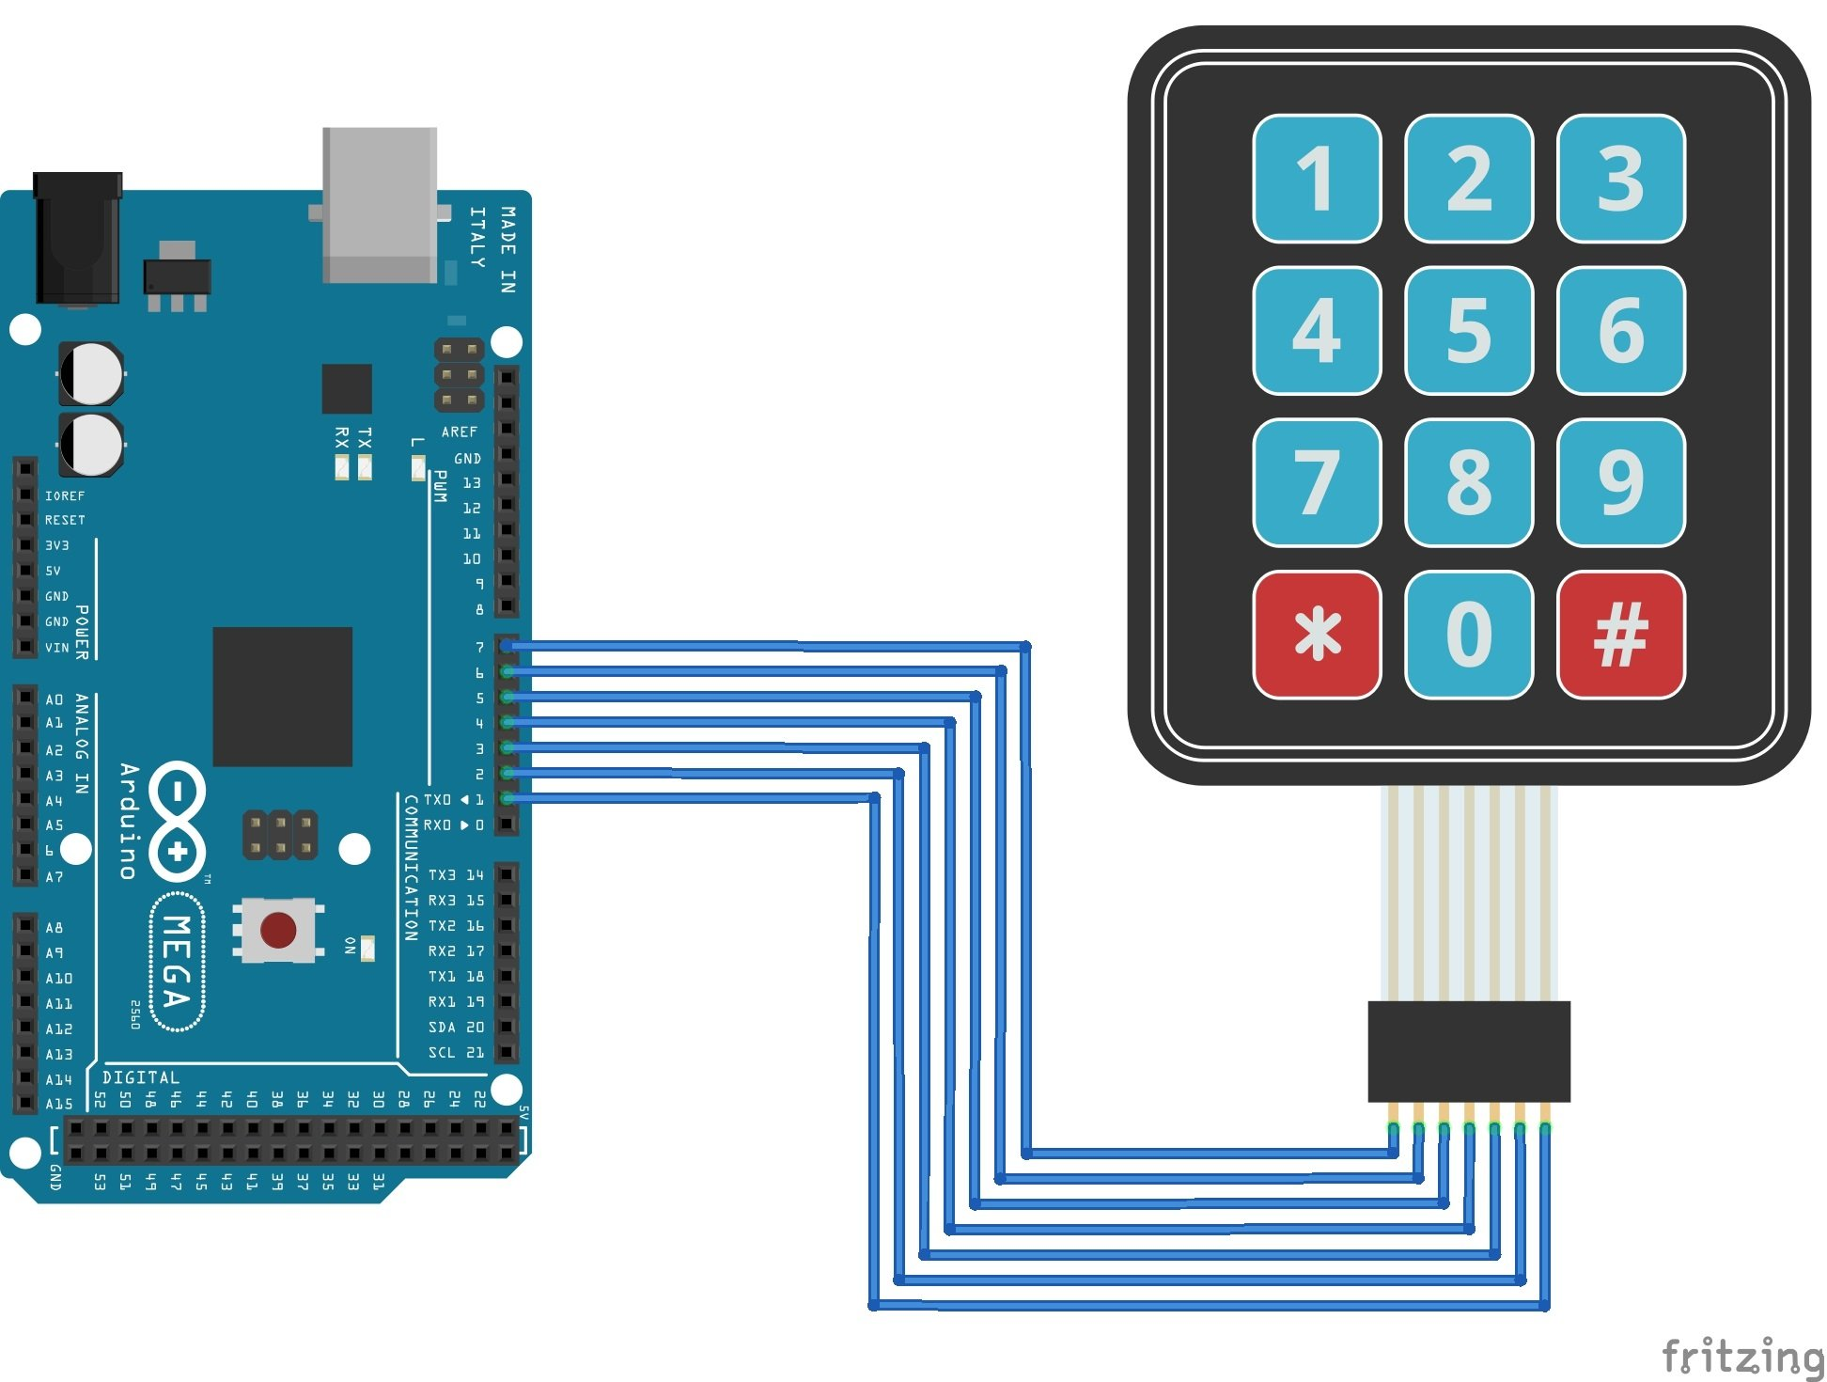

**WIFI Module Keypad Display**

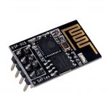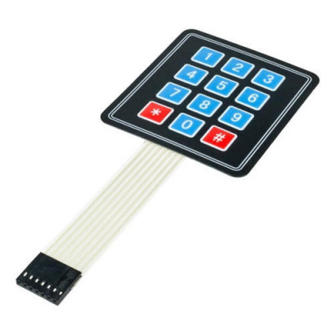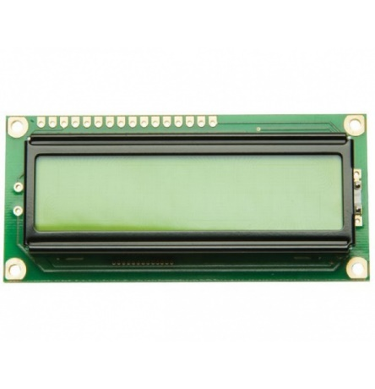

**WORKING OF ARDUINO MEGA BOARD:**

* It will connect to internet using Wi-Fi module.
* Then it will be connected to database.
* It will take input (OTP NUMBER) from the user by using keypad.
* It will display “Please wait” message.
* It will go to database and checks for OTP is present or not.
* If OTP doesn’t match it will display “Wrong OTP” message on display.
* If OTP match, it will get corresponding products ID from database.
* By using products ID, it will send request to the corresponding motors and motors will be rotated so that the required products will be delivered.
* There will be motion sensor which will sense whether the product has felled or not.
* If product has not felled it will again send request to the motor to rotate.
* So that the product will be felled down.
* It will display “Thank you” message.

**WORKING OF ENTIRE MODULE:**

* First, we need to fill up the products in the machine.
* Enter what products and the number of products filled in the machine.
* User should register and login to website.
* He/she has to recharge to their wallet before want to buy products.
* He/she has to select the products and add to cart/click on buy now button.
* Go to cart and click buy now or can modify the quantity and click on pay button.
* The products and OTP are stored in database for feature verification.
* Amount will be deducted form wallet and it will show OTP, which is valid only for 10 minutes.
* Before 10 minutes he/she has to go to vending machine and enter OTP on keypad.
* The vending machine has processing unit which verifies with the database.
* If verification is successful the corresponding motor will rotate and product will fell down.
* If verification is not successful the error will be printed on to the display.
* There will be sensor which will be deducting whether the product will be felled or not.
* If verification is successful and the product has not felled then the motor will rotate again so that the product falls.